TALLY SHEET USER GUIDE

As we collect data at a more granular level, data quality has become a very important component in implementation of people centered approach programming. This is a comprehensive tool that aims at assessing and guiding data and program quality improvement through the collection of data related to a few parameters.

General Guidance:
- Ensure your computer date format is configured as DD/MM/YYYY for the best output of the results from the tool. Please, follow the steps outlined in the document Laptop set up Guide for DQA Excel Tally Tool Application.docx

- Save your Tally Sheet with the following naming convention: Electronic Tally Sheet_(OU Name DQA) - (YYYYMMDD)

Structure of the Tally Sheet

The Tally Sheet is a semi-automated excel based tool to be used for patient file recount when verifying or validating an indicator of your choice, in this case patients on ART. There are ten tabs found on this tally sheet. Out of those, data entry is expected to be done in three of them: Data Entry, CURR Sample Cross-check and DQA Results Summary. All the remaining tabs provide various aggregation formulas which automatically generate information to subsequent tabs for analysis and relevant summary reports.

Instructions Tab:

Select the Reporting Period That You Plan To Do the Assessment: this period at most covers the three months (i.e. a quarter) as defined by the mission or in the implementing partner contract. Only replace the information written in red, if needed, to set the reporting period that will be assessed. The cut-off date is the end of the reporting period being assessed.

Birthday Calculator Tab: in the event that only the age is available in the patients files, use the birth calculator tab to determine the year when this patient was born. As an example, if the first time a patient received HIV services was in 2007 and we found in the patient file that he/she is “ 34 years old” without any information about his/her “date of birth”. As soon as you put 34 in the cell related to the column “Age (years)” and row “2007” of the column “Year on white card”, the year of birth will be displayed as 1973. Therefore, the date of birth for this patient should be recorded as 01/01/1973 using the “DD/MM/YYYY” format.

Data Entry Tab: a tab where all the data will be entered by the assessor. The identifying information from column A - D can be completed prior to the visit to the facility where the assessment will be conducted.

TX_CURR Tally (90 days) tab: no data will need to be entered on this tab. This is a calculation tab that generates the results displayed on tab “Summary DQA results” and “Tally sheet summary”

TX_CURR Tally (28 days) tab: no data will need to be entered on this tab. This is a calculation tab that generates the results on tab “Summary DQA results” and “Tally sheet summary”

TX_NEW Tally tab: no data will need to be entered on this tab. This is a calculation tab that generates the results on the tab “Summary DQA results” and “Tally sheet summary”.

LTFU tab: no data will be entered here due to auto calculation occurring from the data entry tab. Here, patients are identified as lost to follow up either in 28 days per PEPFAR definition, or 90 days per national program definition. PEPFAR definition mandates that - if a patient missed their appointment after 28 days, not on MMD (without any pills) classify as Lost to Follow up. Between the cut off date of 1day to 27th - the patient will be considered a Defaulter. Most PEPFAR funded countries use the National guidelines of 90 days before classifying a patient as LTF or defaulted.

LTFU & DEFAULTER SUMMARIES: No data is required to be entered in this tab which is used to generate lists of patients identified as “defaulters” or “LTFU” considering the 28 days or 90 days guidance. This list is supposed to be given to the health facility manager in order to track these patients in a perspective of program quality improvement. Please, refer to step 4 below in order to understand better the process needed to generate such lists.

Tally Summary tab: This tab is automated to be filled with results from calculations based on the data entered in the “Data Entry tab”. We can see aggregated numbers of pateints current on ART (TX_CURR); active and defaulters diaggregated by age and sex at 90 days and 28 days; Patients newly enrolled on ART monthly (TX_New); and lost to follow up at 28 and 90 days.

CURR SAMPLE CROSSCHECK tab: It’s expected that data from two different sources will be entered for a sample of patients in order to cross-validate patients information available in the main data source (used for reporting). 5% of the patients files will be pulled for cross-validated if there are more than 500 patients currently on treatment in the facility being assessed; or 10% if less.

DQA RESULTS SUMMARY tab: The columns “Recounted” will be pre populated from the content of tab “Tally Summary”. However, Column C (PEPFAR Reported TX_CURR) and Column H (PEPFAR Reported TX_NEW) will need to be filled out with quarterly reported data from DATIM.

How to Complete the Tool

Step 1: From instruction tab
- Select the reporting period that you plan to do the assessment. This period at most covers the three months (i.e. a quarter) as defined by the mission or implementing partner contract.
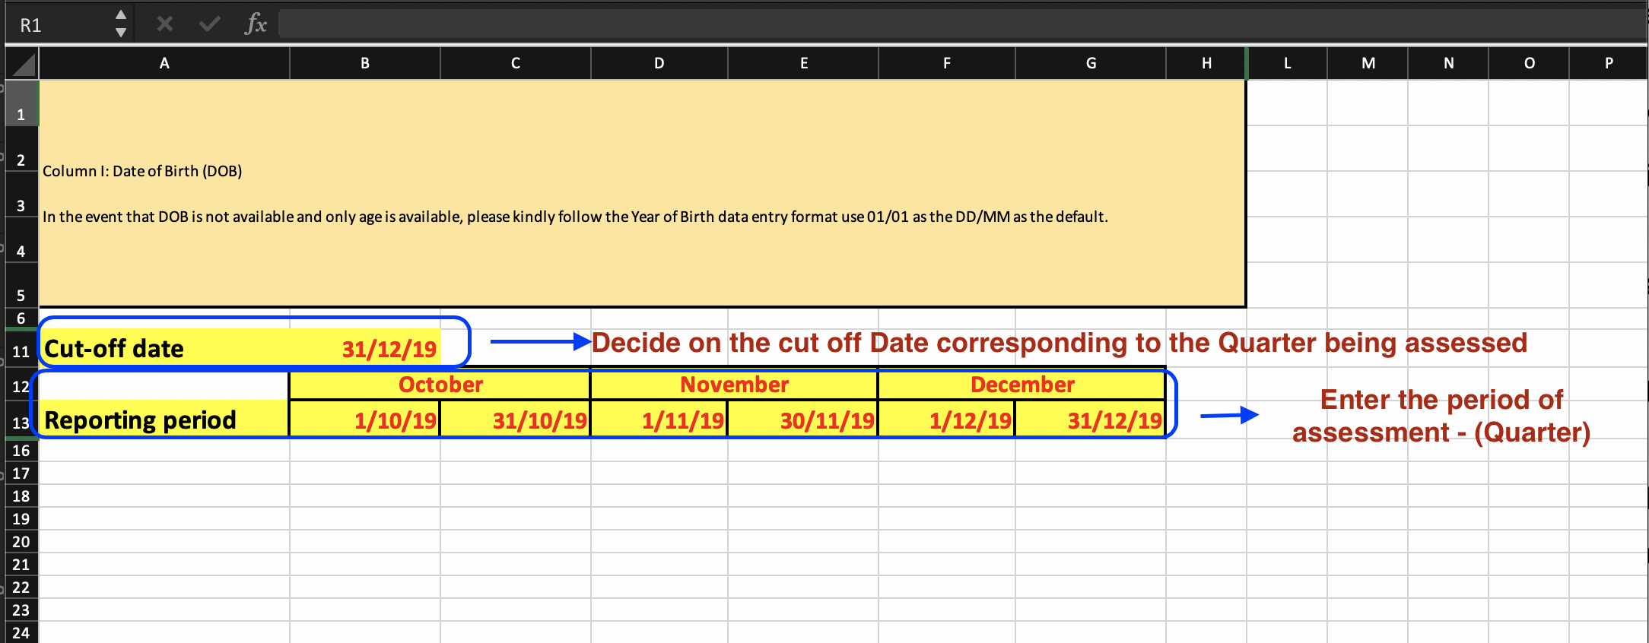

Step 2: Data Entry Tab: this is where you will do all your Data Entry. The Cut-Off Date and the assessed Quarter dates will be automatically pulled as provided on the Instruction Tab. Since the information entered on this tab is entered manually, it is important that the correct date format is used so the inbuilt formulas used for calculations are not altered. As highlighted below, the first 4 columns can be filled out prior to the facility visit.

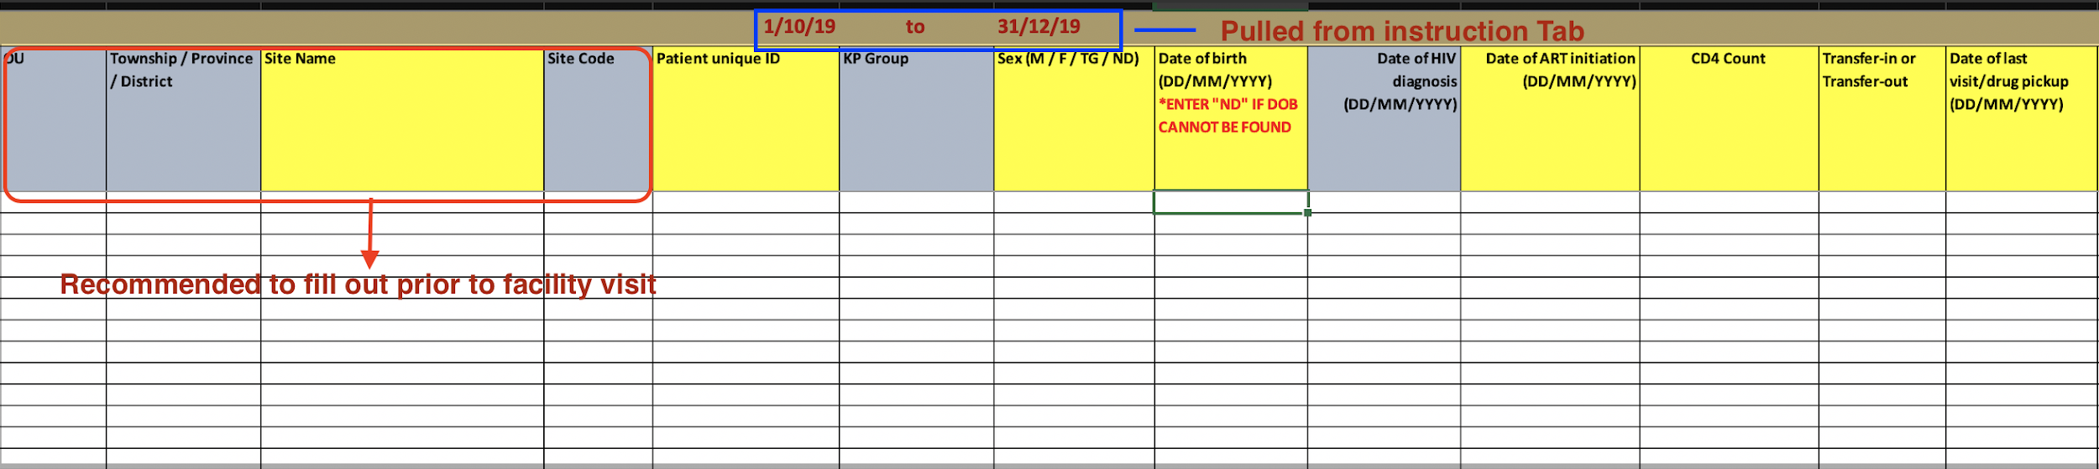

Step 3: Lost to Follow Up and Defaulters Tab – As soon as data has been entered in “Data Entry Tab”, it’s possible to generate the list of patients “LTFU” or “Defaulters”. As highlighted below, you have only to refresh the page by following these steps: Click Data then Refresh all. By doing so, a list of LTFU and Defaulters will be pulled for further review, analysis and confirmation.

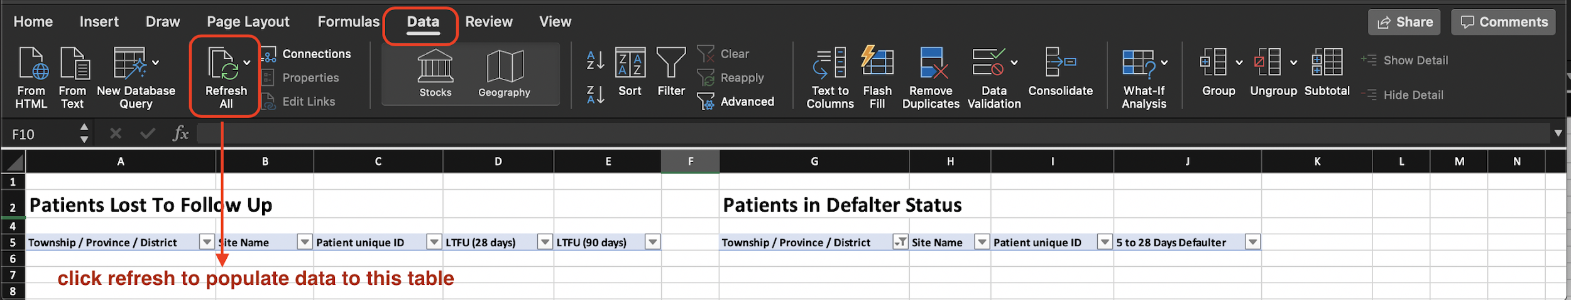

Step 4: DQA RESULTS Summary Tab: Majority of the data found on this tab will be pre-populated with the exception on the column C and H where you must manually enter PEPFAR reported data found on DATIM for TX_CURR and TX_New. A sample calculation will also be done on this tab see screenshot where, 5% of charts will be manually re-assessed for comparison analysis of data reported against created to get concordance and identify areas of over and/or under reporting.
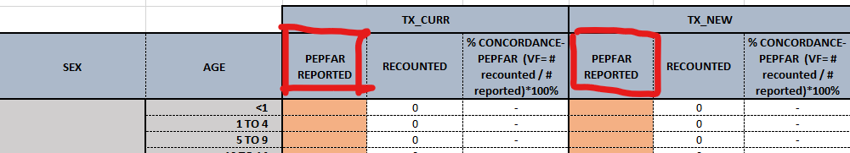

On the chart crosscheck Tab - a formula is used to calculate, (Number of patients currently on ART sampled from register), the number of files that will be randomly selected using the following calculation: 5% of files for facility with more than 500 patient currently on ART and 10% for facility with less than 500.

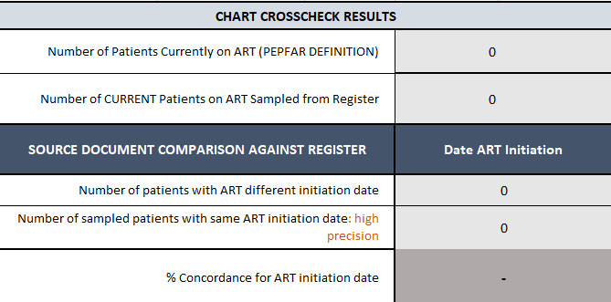

Quality Check - Review of Completed Tool

- Review the Date Format conformity as instructed
- Review the data entry Tab for errors, consistency between critical data points and missing information. As an example, double-check consistency between date of HIV test and Date of ART initiation
- Provide feedback to:
  - facilities at the end of the assessment
  - Mission teams on where corrections are needed
- Draft a report by analyzing the trend observed during tool review process
- Give guidance on areas where they warrant a Small Test of Change (STOC) to institutionalize continuous quality improvement culture.

What you will get out of the tool
a) List of patients that are:
- LTFU
- Defaulters
- eligible but without Viral Load test done
- eligible but not on MMD
b) compliance or issues with implementation of “test and treat”
c) accuracy of data reported through DATIM on TX_CURR, TX_NEW
d) consistency between the two main data sources (dispensation register and patients file) etc…

Tool Implementation Best Practice

- Clear understanding of PEPFAR indicators specifically how to define Lost to Follow up/ Defaulters, TX_NEW, TX_CURR. Understanding the definition of the indicators and the terminology used will aid the team in file selection to include as part of the DQA process.
- Conduct basic accuracy checks during data entry to identify any errors for example:
  - where date is required - display a full year DDMMYYYY instead of DDMMYY to notice an obvious error where “9187” was typed instead of “1987”
  - Use column filter where dates are required to confirm
- There is a balance between accuracy and speed. Take breaks and switch roles in the team between reading the file and entering data to stay alert.
- Data entry person should repeat the entry out loud as they type.
- Patient files typically do not include a DOB, and only include the patient’s age and date of first visit. Ensure you are looking at the correct date of first visit for the DOB calculation. It is not necessarily the same as the date of diagnosis or initiation.Look inside the file to verify the DOB/age if unsure.
- Where patient files do not include the dosage, the calculation is based on last and next visit dates. If the date difference was not an exact dosage, suggestions are to round the number (91 days between appointments; round to 90). If it is an unusual figure (e.g. 75 days), look at the other visit dates to see if the typical dosage and see they came early or late.

