TALLY SHEET USER GUIDE

As we collect data at a more granular level, data quality has become a very important component in implementation of people centered approach programming. This is a comprehensive tool that aims at assessing and guiding data and program quality improvement through the collection of data related to a few parameters.

General Guidance:
- Ensure your computer date format is configured as DD/MM/YYYY for the best output of the results from the tool. Please, follow the steps outlined in the document Laptop set up Guide for DQA Excel Tally Tool Application.docx

- Save your Tally Sheet with the following naming convention: Electronic Tally Sheet_(OU Name DQA) - (YYYYMMDD)

Structure of the Tally Sheet

This Tally Sheet is a semi-automated excel based tool to be used for patient file recount when verifying or validating an indicator of your choice, in this case “patients on ART”. There are 7 tabs in this tally sheet. Out of those, data entry is expected to be done in three of them: “Data Entry-1”, “CURR Sample Cross-check” and “DQA Results Summary”. All the remaining tabs provide various aggregation formulas which automatically generate information to subsequent tabs for analysis and relevant summary reports.

Instructions Tab: in this tab, you are requested to tailor the tool to your country context and your specific needs. You will need to fill out all the cells highlighted in yellow. In the cells highlighted in yellow enter specific information related to the period of the DQA (cut-off date and reporting periods) and the specific characteristics of the country /OU where the DQA is being conducted (OU, State, District, Site Name, Site Type).

Those data will be prepopulated in a drop-down menu for each relevant data point (OU, State, District, Site Name, Site type) in the Data Entry - 1 tab. Please, make sure that you scroll down the menu until the far bottom

Please, be aware that it is generally expected that a DQA will focus in only one quarter and the “cut-off date” is the last day of the quarter being assessed. As an example, for the quarter October – December 2020, the cut-off date is December 31, 2020.

Data Entry-1 Tab: a tab where all the data will be entered by the assessor. The identifying information from column A - D can be completed prior to the visit to the facility where the assessment will be conducted.

Data Entry-2 Tab: No data will need to be entered in this tab which is just a copy of “Data Entry -1”. However, in this tab, the data points “Patient ID” and “Date of birth” have been removed in order to avoid potential issues of handling “personally identifiable information”.

IIT & DEFAULTER SUMMARIES: No data is required to be entered in this tab which is used to generate lists of patients identified as “defaulters” or “IIT” considering the 28 days or 90 days guidance. This list is supposed to be given to the health facility manager in order to track these patients in a perspective of program quality improvement. Please, refer to step 4 below in order to understand better the process needed to generate such lists.

Tally Summary tab: This tab is automated to be filled with results from calculations based on the data entered in the “Data Entry tab”. We can see aggregated numbers of patients current on ART (TX_CURR); active and defaulters disaggregated by age and sex at 90 days and 28 days; Patients newly enrolled on ART monthly (TX_New); IIT at 28 and 90 days; Patients tested positive (HTS_ POS) during the quarter under review (aggregate and monthly).

CURR SAMPLE CROSSCHECK tab: In this tab, it’s expected that data from two different sources will be entered for a sample of patients in order to cross-validate patients’ information available in the main data source (used for reporting). 5% of the patients files will be pulled for cross-validation if there are more than 500 patients currently on treatment in the facility being assessed; or 10% if there are less than 500 patients.

DQA RESULTS SUMMARY tab: The columns “Recounted” will be prepopulated from the content of tab “Tally Summary”. However, Column C (PEPFAR Reported TX_CURR), Column F (PEPFAR Reported TX_NEW) and Column I (PEPFAR Reported HTS_POS) will need to be filled out with quarterly reported data from DATIM.

How to Complete the Tool

Step 1: Set-up your computer
Please, ensure that: 1) the date format on your computer is set up as "dd/mm/yyyy"
2) all dates in this template must be entered as "dd/mm/yyyy"
3) data entry must be performed only on the tab "Data Entry - 1"

Step 2: “instructions” tab
- Replace or fill out the cells highlighted in yellow (see below) with relevant information in order to tailor the tool to the country context and the specific needs for the DQA. Please, be aware that the reporting period (October -December 2019) already available is an example and must be replaced depending on the quarter that will be assessed.
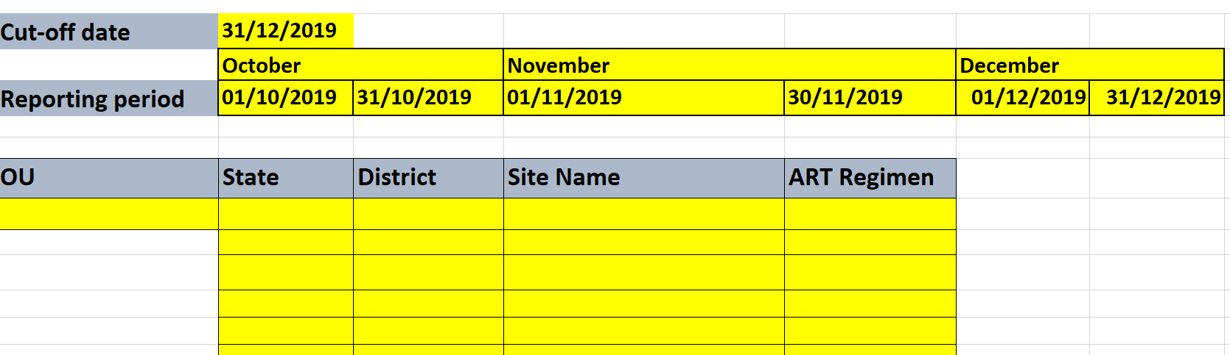

Step 3: Data Entry-1 Tab:
- In each row, enter data related to one individual patient. The Cut-Off Date and the assessed Quarter dates (Start and End dates) will be automatically displayed, based on what was entered in the “Instructions” Tab. Since the information entered on this tab is entered manually, it is important to ensure that the correct date format is used so the inbuilt formulas used for calculations are not altered. As highlighted below, the first 4 columns can be filled out prior to the facility visit.

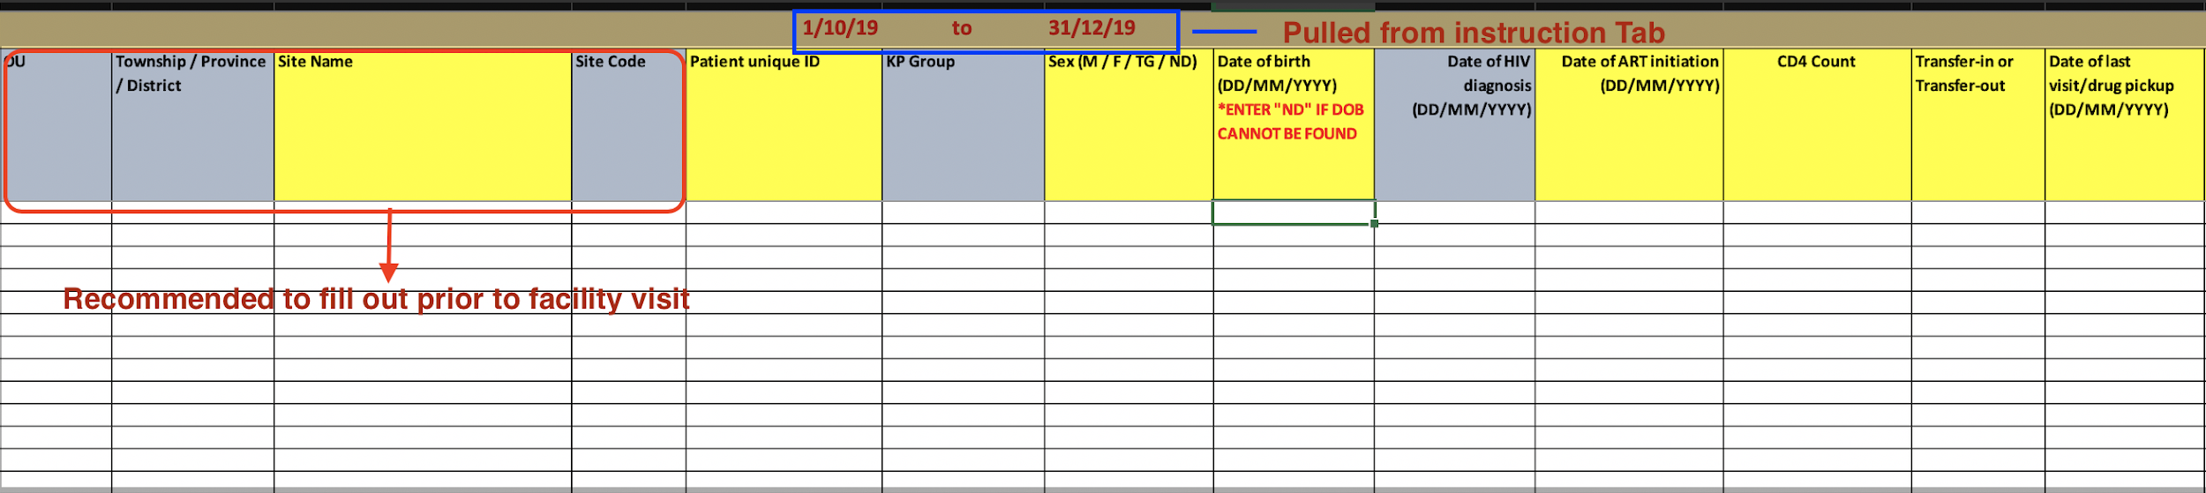

Step 4: IIT and Defaulters Tab – As soon as data has been entered in “Data Entry Tab”, it’s possible to generate the list of patients “IIT” or “Defaulters”. As highlighted below, you have only to refresh the page by following these steps: Click Data then Refresh all. By doing so, a list of IIT and Defaulters will be pulled for further review, analysis and confirmation.

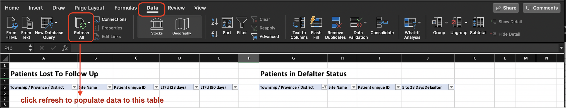

Please, be aware that more specific guidance can also be found in columns “L - Q” of the tab.

Step 5: CURR SAMPLE CROSSCHECK tab
In columns “B – F”, enter data extracted from the “primary data source” for each individual patient randomly selected. In columns “G – K”, enter data extracted from the “secondary data source” for each individual patient randomly selected for cross-validation. There is no expectation to enter data in columns “V-Z”. Those columns (V-Z) will be automatically filled out with “SAME” if there is no difference between the two data sources or with “DIFFERENT” otherwise.

Step 6: Data Entry-2
At the end of the DQA process and after sharing the list of patients generated in tab "IIT & DEFAULTER SUMMARIES” with the service providers in the facility, go to the tab "Data Entry - 2" then:
a) select all data
b) click on "copy"
c) click on "Paste Special" + "Values"
3) Double-check to make sure that all data in the tab "Data Entry - 2" are values, not "formulas".
4) Then delete from the worksheet the tab "Data Entry - 1"

Step 7: DQA RESULTS Summary Tab:
Most of the data in this tab will be pre-populated with the exception on the column C, F and I where you must manually enter PEPFAR reported data found on DATIM for TX_CURR, TX_NEW and HTS_POS for the quarter being reviewed.
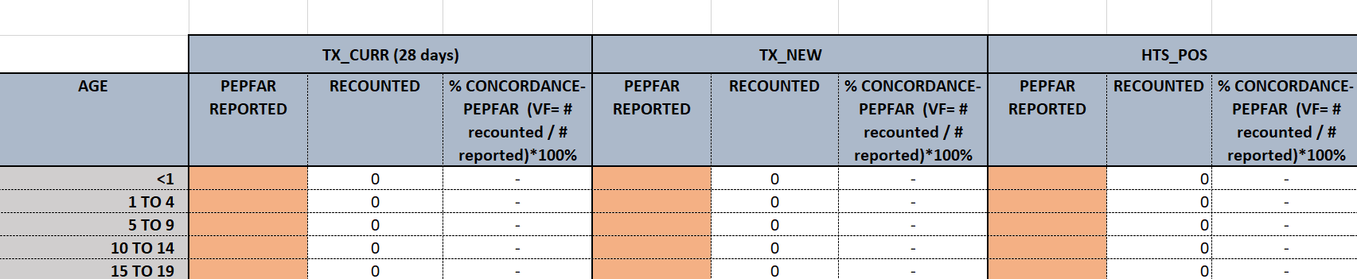

The formula to get the size of the sample of patients to be selected for cross-validation is integrated into this tab. The related value can be found in row 59 “Number of CURRENT Patients on ART Sampled from Register”. As already flagged, the sample size will be
5% of files for facility with more than 500 patients currently on ART and 10% for facility with less than 500.

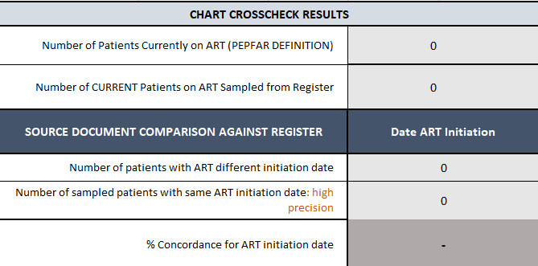

Quality Check - Review of Completed Tool

- Review the Date Format conformity as instructed
- Review the “Data entry - 1” Tab for errors, consistency between critical data points and missing information. As an example, double-check consistency between “date of HIV test” and “Date of ART initiation”
- Provide feedback to:
  - facilities at the end of the assessment
  - Mission teams on where corrections are needed
- Make sure that you didn’t forget to follow “Step 6” related to the tab “Data-Entry 2” and there is no “Personally Identifiable Information (PII)” in the tally sheet at the end of the DQA in each facility
- Draft a report by analyzing the trend observed during tool review process

What you will get out of the tool
a) List of patients that are:
- IIT
-Defaulters
- eligible but without Viral Load test done
- eligible but not on MMD
b) compliance or issues with implementation of “test and treat”
c) accuracy of data reported through DATIM on TX_CURR, TX_NEW and HTS_ POS
d) consistency between the two main data sources (dispensation register and patients file) etc…

Tool Implementation Best Practice

- Clear understanding of PEPFAR indicators specifically how to define IIT / Defaulters, TX_NEW, TX_CURR, HTS_POS. Understanding the definition of the indicators and the terminology used will aid the team with files selection to include as part of DQA process.
- Conduct basic accuracy checks during data entry to identify errors for example:
  - where date is required - display a full year DDMMYYYY instead of DDMMYY to notice an obvious error where “9187” was typed instead of “1987”
  - Use column filter where dates are required to confirm
- There is a balance between accuracy and speed. Take breaks and switch roles in the team between reading the file and entering data to stay alert.
- Data entry person should repeat the entry out loud as they type.
- Patient files typically did not include a DOB, and only included the patient’s age and date of first visit. Ensure you are looking at the correct date of first visit for the DOB calculation. It is not necessarily the same as the date of diagnosis or initiation. Look inside the file to verify the DOB/age if unsure.
- Patient files did not include the dosage, so this was calculated based on last and next visit dates. If the date difference was not an exact dosage, we rounded the number (91 days between appointments: round to 90). If it is an unusual figure (e.g. 75 days), look at the other visit dates to see if the typical dosage and see they came early or late.

