**Guiding laptop set up for smooth application of the Excel-based DQA Tally tool**

1. **Please go to your laptop control panel and select ‘Clock, Language, and Region’**

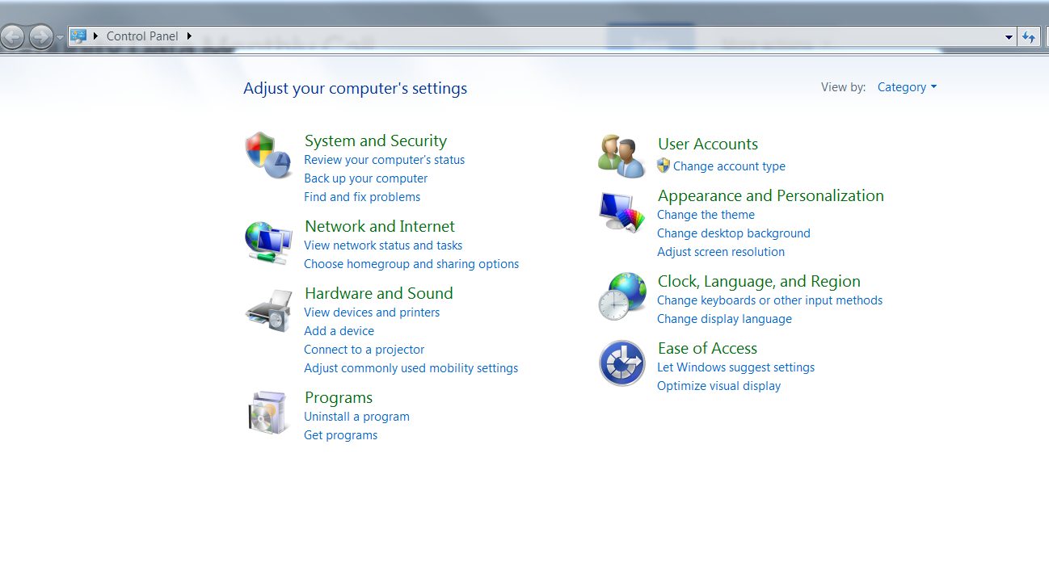

1. **Within the next screen select ‘Change the date, time, or number format’**

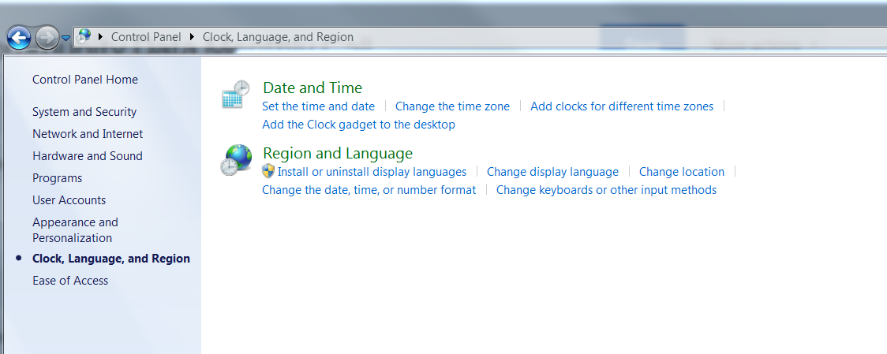

1. **The next screen should be adjusted to show the date format as appearing in the screen shot below:**

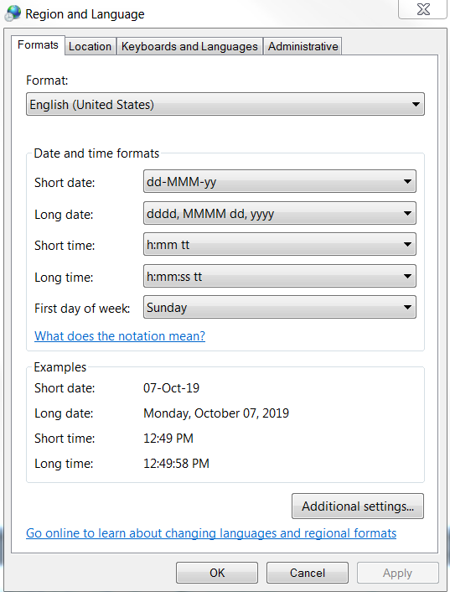

1. **The last thing to do is to APPLY this setting to your computer and close the control panel.**